# Software Project Management and Quality Assurance

## Practical – 1

For finding Project Management Software, I used keyword “***project managing tools***” for searching the internet.

I found out following tools from [this](https://kissflow.com/project/best-project-management-tools/) website:

->Kissflow

->Trello

->Asana

->Zoho projects

->Wrike

->Monday.com

->Proof hub

->Clarizen

->Airtable

->Kanban Tool

->Zenkit

->Meister Task

->Click Up

->Paymo

->Teamwork

I found out following tools from [other](https://www.scoro.com/blog/best-project-management-software-list/) website as follows:

->Scoro

->ProofHub

->Basecamp

->Asana

->Citrix Podio

->Workzone

->Jira

->Notion

->Trello

->Active Collab

->Redmine

->Zoho Projects

->Deltek Workbook

->Fuction Box

->Nutcache

->WORKetc

->Cage

->Paymo

->BrightPod

->Liquid Planner

->Microsoft Project

->Weekdone

->Bitrix24

->Redbooth

->MindGenius (Barvas)

->ClickUp

->Avaza

->Toggl Plan (Teamweek)

->Teamwork

->FreedCamp

->Advantage

->Easy Project

->ProWorkflow

->SmartSheet

->Celoxis

->Insightly

->Copper Project

->Clarizen

->ProjectManager.com

->Ravetree

->Highrise

As we can see comparing examples from both the websites that most of them are same. Majority of Software have similar characteristics that are required for Project Management. Features that distinguish between each other are generally User Interface, Pricing, and some other features which are peculiar to the company or individual using. For example, if a company starts using a particular software and gets acquainted with it then if that software requires subscription then they need to invest in it as employees are set with that particular software and changing that will take time and may hinder current on-going projects which in-turn affects the company growth.

**I have selected this 3 major software:**

-> Zoho

-> Microsoft Project

-> Trello

**Comparison of these three software:**

|  |  |  |  |
| --- | --- | --- | --- |
|  | **Zoho** | **Microsoft Project** | **Trello** |
| **Calendar View** | Available | Available | Available |
| **Price** | Rs. 800 – Rs. 2600 per user per month | Rs. 720 – Rs. 5000 per user per month | Rs. 0 – Rs. 1000 per user per month |
| **Mobile App** | Available | Available | Available |
| **Desktop App** | Available | Available | Available |
| **Free Trial** | Yes | Yes | Yes |
| **Interface** | Easy to Use | Takes time to adapt but very efficient | Easy to Use |
| **Time Tracking** | Yes | Yes | Yes |

Majority of Software have very similar characteristics but its matter of consistency. Once a company starts using a particular software it can’t change the software due to obvious reasons which every company needs to remember and take a note while choosing project managing software.

1. Zoho

This software is very user-friendly and is completely easy to learn. Company who just started can afford and is easy for them to get acquainted with it. Employees can easily learn this software given they are through with basics of project management tools.

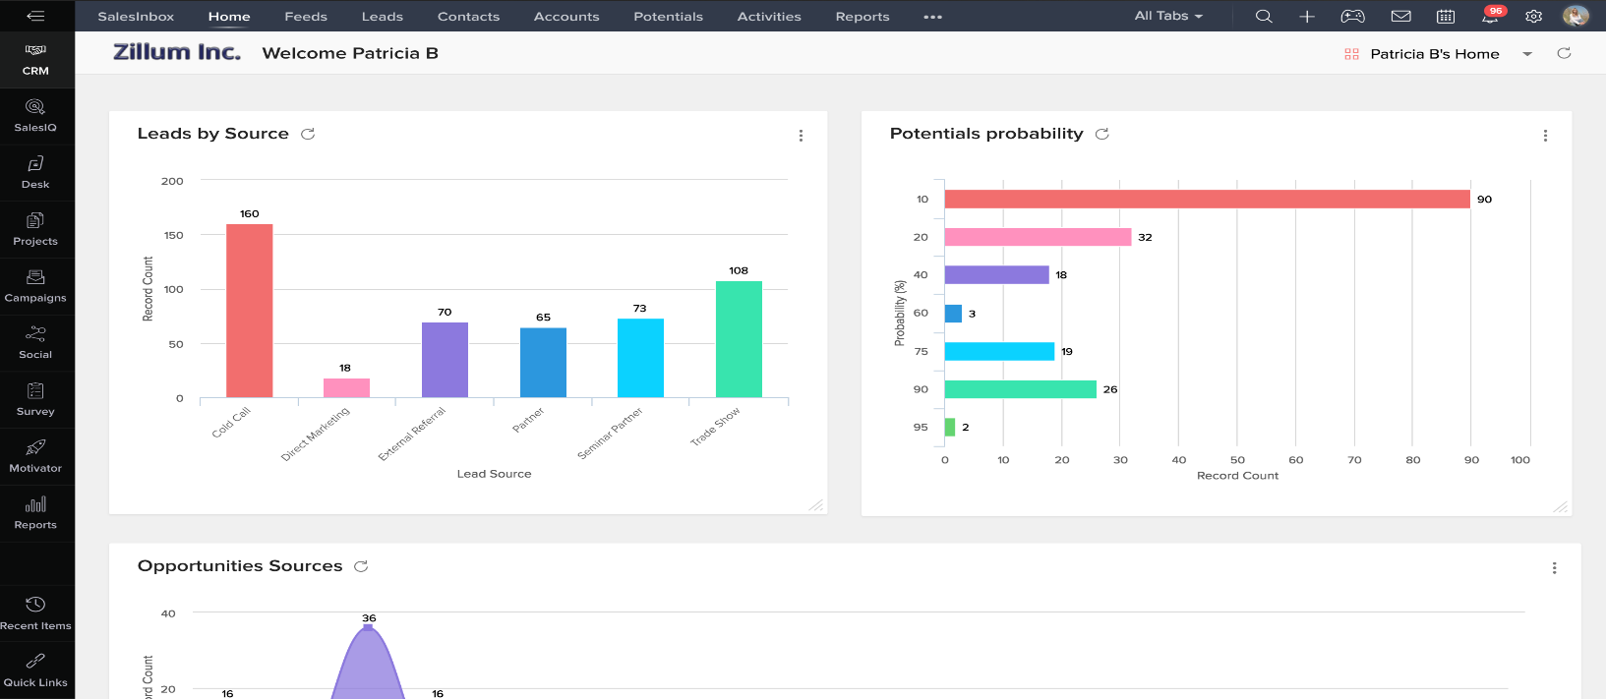

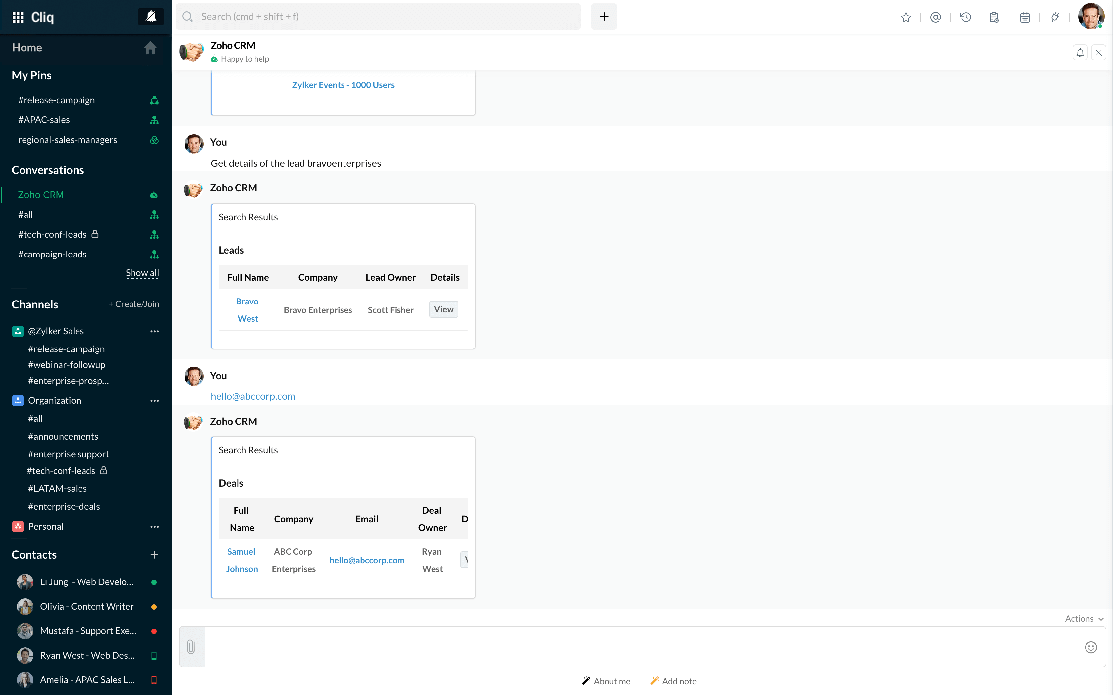

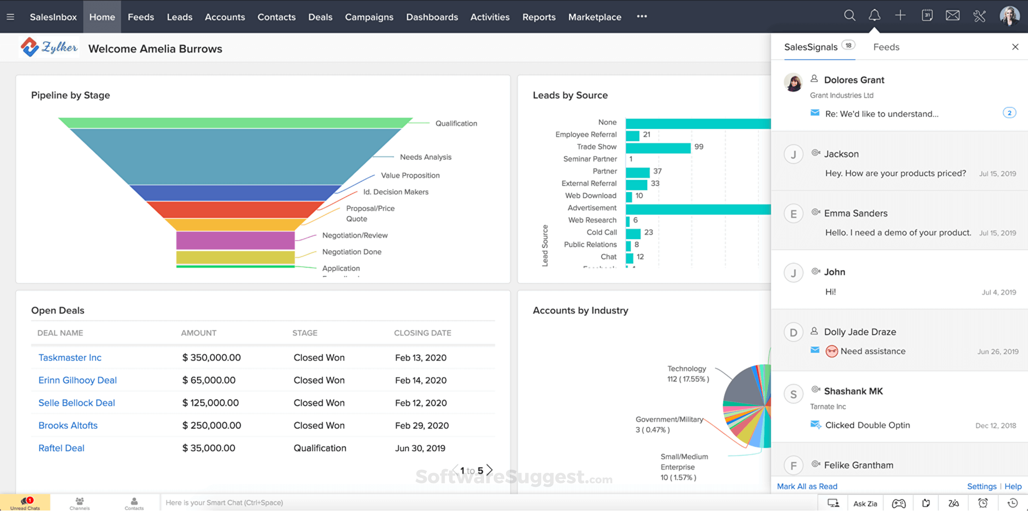

1. Microsoft Project

This software having maximum number of functions and a fair user-friendly UI with it. But for employees who are not familiar with Microsoft Projects specifically, they will take time to learn. If company can afford, then they can provide some courses that will make them familiar with Microsoft Projects. Once learned, it will be very beneficial for company in terms of Project Management and overall company development.

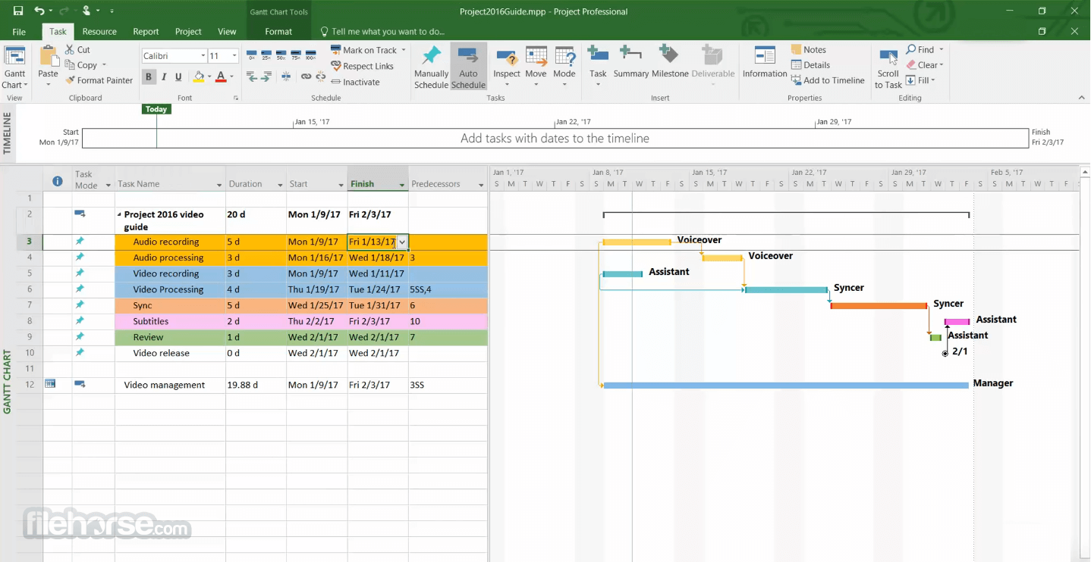



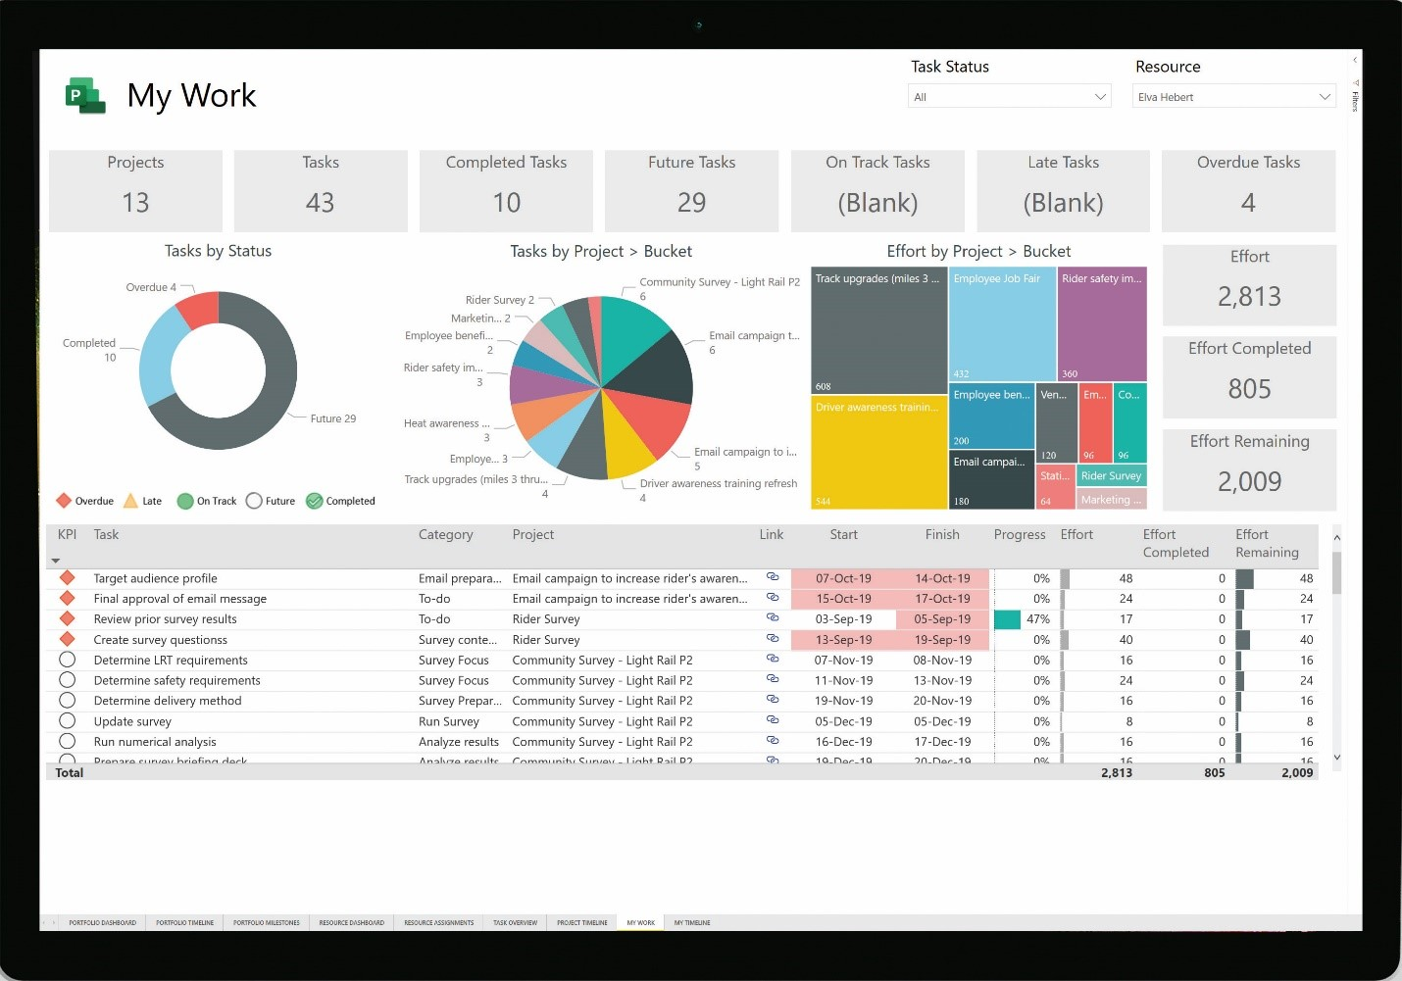

1. Trello

Trello is comparatively less user friendly if we try to compare it with other software as we discussed above and overall UI is less appeasing then other software. Thus, I decided not to choose this software.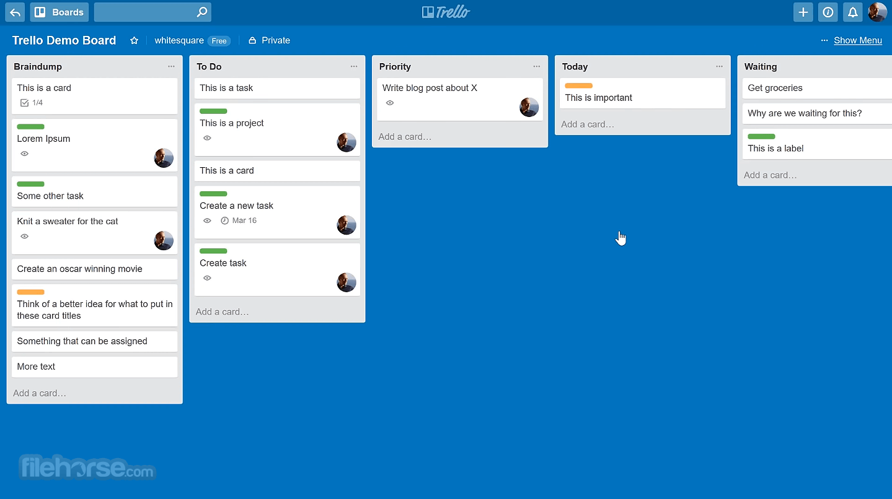

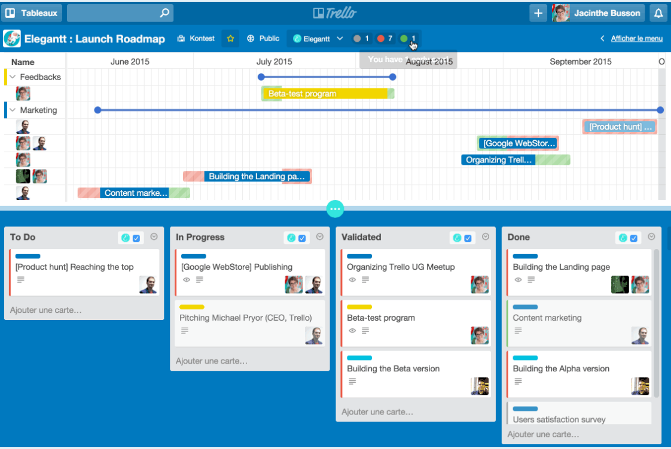

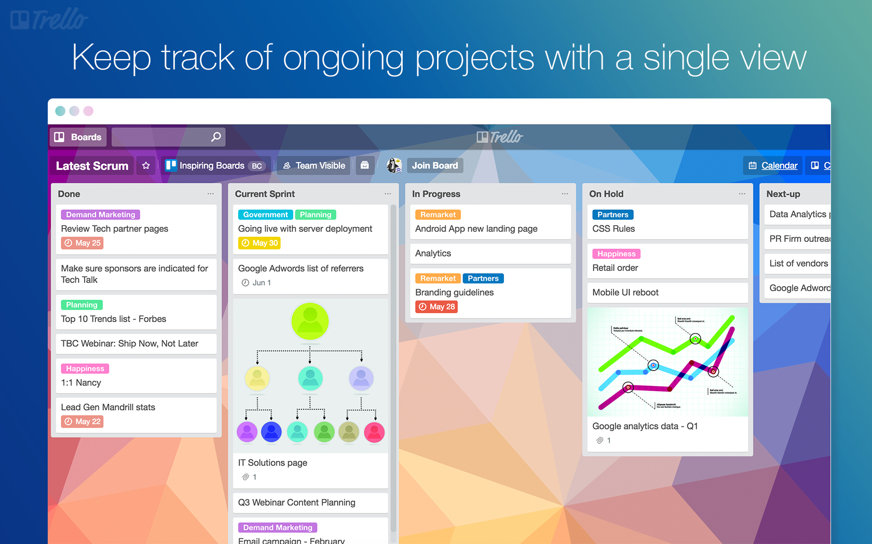

I would like to prefer **Microsoft Projects** over other due to following reasons:

-> Company name of Microsoft

-> Proper Customer Feedback

-> They ensure Customer Satisfaction

-> If in case of any problem, quick solution is guaranteed

-> Easy data backup is available which might not be available in other software due to Microsoft Drive.

***References:***

<https://kissflow.com/project/best-project-management-tools/>

<https://www.scoro.com/blog/best-project-management-software-list/>

<https://www.microsoft.com/en-in/microsoft-365/project/project-management-software>

<https://trello.com/en>

<https://www.zoho.com/>